LANCASHIRE COUNTY TOWELS AND HATS

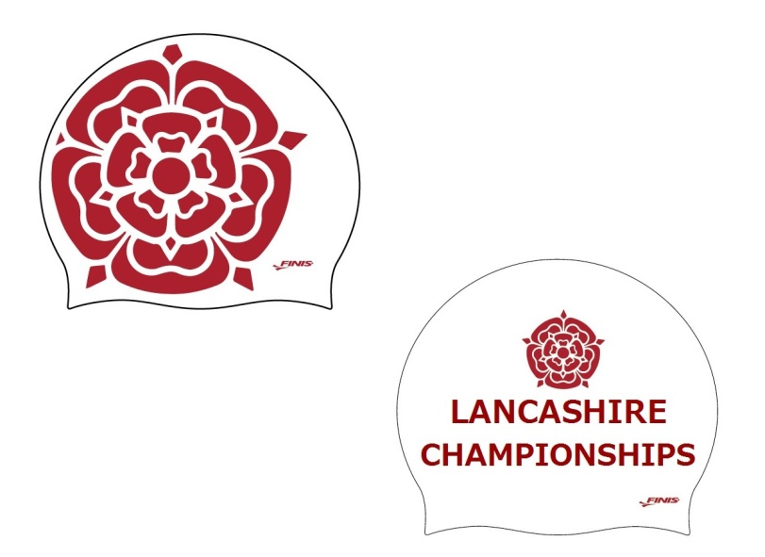

TOWEL £20 CAPS £7
Lancashire County towels and swimming caps are only available to order prior to the County Championships as a club order. If you wish to purchase any items please complete the order form below.
Please make cheques payable to Chorley Marlins ASC or make a BACs transfer to Barclays bank account no. 73783138 sort code 206985. DEADLINE FOR ORDERS is December 10th 2016

Name of Swimmer__________________________________________
Contact Telephone Number__________________________________
Payment method: BACS or CHEQUE____________________________
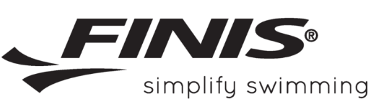
Please return forms and cheques to the Marlins post box or return forms via email to competitions@chorleymarlins.org.uk making bacs payments by December 10th 2016.
NO LATE ORDERS WILL BE ACCEPTED.
 | NUMBER REQUIRED | COST
TOWEL £20 |  | £
HAT £7 |  | £
 | TOTAL COST | £

All products ordered will be available for collection from Paula Dobbs at Manchester Aquatics on the 28th January 2017.

